Stats Video Lectures – Normal Distribution

Week 2, Lecture 8

1. Normal Distribution
   1. most distributions in nature follow the normal distribution
   2. such as the bell curve
   3. unimodal
   4. symmetric
   5. follows strict rules about how variable the data may be
   6. mu the center is 0, sigma the standard deviation is 1 in a normal dist
2. **68-95-99.7% rule**
   1. 68% of the data falls within 1 st dev of the mean
   2. 95% of the data falls within 2 st dev of the mean
   3. 99.7% of the data falls within 3 st dev of the mean
3. standardized scores (zscores)
   1. The Z-score of an observation is the number of st dev it falls above or below the mean
   2. $Z=\frac{obv-mean}{St Dev}$**aka in R z <- pnorm(x, mean, st dev)**
   3. z score of the mean is 0
   4. unusual observations are usually defined as |Z| >2
   5. works for any dist, not just the normal dist
4. probabilities and percentiles
   1. when the dist is normal, then Z can be used to calculate the percentile
   2. Percentile is the percentage of observations that fall below a given data point
   3. Represented on a normal graph as the area below the prob dist curve to the left of the observation
   4. using R
      1. pnorm gives the percentile of the observation with a given mean and st dev

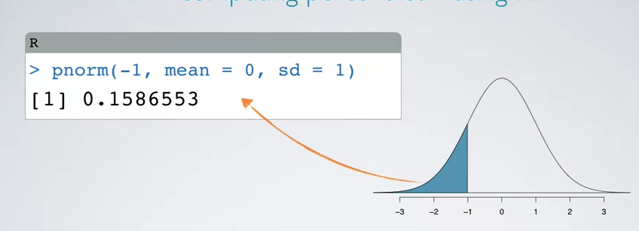

* 1. using a normal prob table
     1. I will always have access to R
  2. finding cutoff values for percentiles
     1. given a percentile of z, then 1-z is the cut off, and z $=\frac{obv-mean}{St Dev}$**.** Assuming the parameters are known, obv = (z*st dev )+ mean

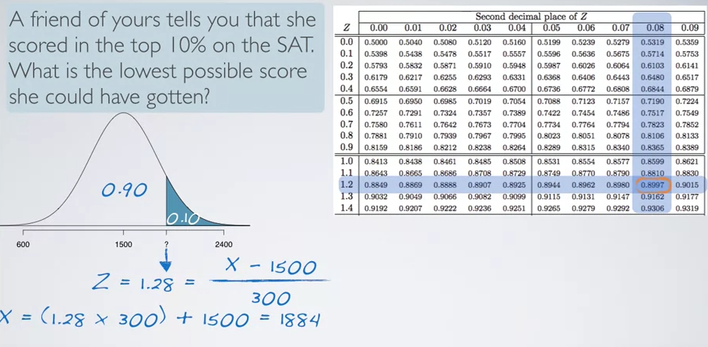

* + 1. the same thing in **R score_cutoff <- qnorm(percentile, mean, st dv)**
    2. 